Greenhouse project

Embedded Operating Systems VIA UC

November 2017

Silvija Krupaviciute

Dmitry Rachkovsky

Table of Contents

Introduction 1

Greenhouse Model 2

Light Intensity Sensor 2

Circuit 2

Pins 2

Code 2

Usage 2

Light Intensity Control 2

Circuit 2

Pins 2

Code 2

Usage 2

Temperature and Humidity Sensor 2

Circuit 2

Pins 2

Code 2

Usage 2

Servo Motor Control 2

Circuit 2

Pins 2

Code 3

Usage 3

Heater Control 3

Circuit 3

Pins 3

Code 3

Usage 3

# Introduction

There are several aspects that need to be taken in consideration while creating a greenhouse control system. The greenhouse flora need optimal levels and duration of **daylight** for photosynthesis and plant respiration. **Ventilation** is also one of the most important components in a successful greenhouse in order to prevent bacteria and infections due to humid environment, regulate the temperature when it gets too hot and ensure air movement to prevent buildup of necrotic fungus. Finally, the **heating** is important for the greenhouse to operate properly in colder climates. Therefore, the main aspects that need to be considered are:

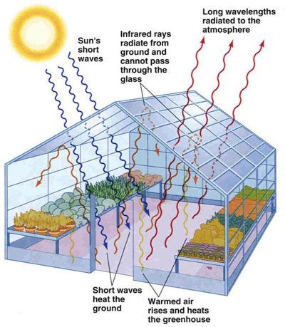Monitoring:

* Humidity
* Temperature
* Daylight

Environment Control:

* Window Opening
* Heater
* Artificial Daylight

User Interface:

* Web Interface for Monitoring and Controlling remotely

# Greenhouse Model

|  |  |
| --- | --- |
| Feature | Technology |
| Measure temperature | I2C bus |
| Measure Humidity | I2C bus |
| Measure Light Intensity | Analog |
| Control servo motor for window | PWM |
| Control heater | Digital on/off |
| Control light intensity | PWM |
| Monitor and control remotely | Node.js server, RESTful API |

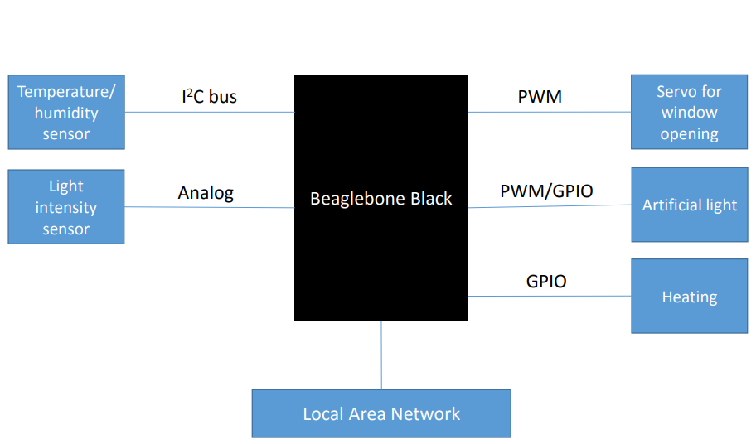

# Light Intensity Sensor

## Circuit

## Pins

## Code

## Usage

# Light Intensity Control

## Circuit

## Pins

## Code

## Usage

# Temperature and Humidity Sensor

## Circuit

## Pins

## Code

## Usage

# Servo Motor Control

## Circuit

## Pins

## Code

## Usage

# Heater Control

## Circuit

## Pins

## Code

## Usage